1. a)
Aggregate demand type 1:Q1=100*(1000-100p)=100,000-10,000p
Q1=1000-100p
P=10-0.01q1
MR1=10-0.02q1
Aggregate demand of type 2:Q2=100*(400-50p)=40,000-5000p
Q2=400-50p
P=8-0.02Q2
MR2=8-0.04Q2
b).
The optimal quantity in market type1,
Profit maximizing condition: MR= MC
Given MC=0
So,MR1=MC
10-0.02q1=0
Q1*=10/0.02=500
Optimal quantity in market type 2,
MR2= MC
8-0.04q2=0
Q2*=8/0.04=200
c)
Optimal price in market type 1,
P1=10-0.01*500=5
Optimal price in market type 2,
P2=8-0.02*200=4
d)
Total revenue= Total revenue from market 1 + total revenue from Market 2
Total revenue=100*5*500+100*4*200=2500+800=330,000
Total cost = 10,000
Profit=330,000-10,000=320,000

2.
- No strategy is a dominant strategy for either player.
- There are two Nash equilibria on (C, A) and (A, C).
 | A | B | C
A | -10 , -10 | 0, 10 | 10, 20
B | 10 , 0 | -20, -20 | -5, 15
C | 20 , 10 | 15, -5 | -30, -30
The playoffs that have been underlined are the best equilibrium strategies of each of the players given the strategies of the other players.
- Player 1 maximum strategy given his playoffs is given below:
 | A | B | C | Minimum
A | -10 | 0 | 10 | -10
B | 10 | -20 | -5 | -20
C | 20 | 15 | -30 | -30
 |  |  | Maximum = | -10
Similarly for player 2,
 | A | B | C | Minimum
A | -10 | 10 | 20 | -10
B | 0 | -20 | 15 | -20
C | 10 | -5 | -30 | -30
 |  |  | Maximum = | -10
If both networks are rsk averse, then the euillibrium will be (A, A)
- When the firm uses the maximum strategy i.e. ‘A’ and it is known to firm 2, then firm 2 gets the maximum profit from ‘C’.

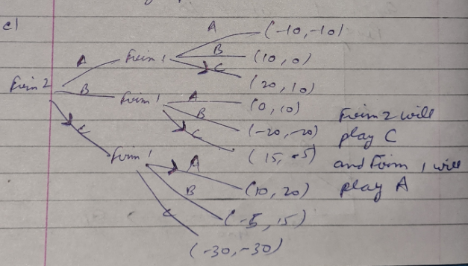

3.
a).
Consider the given issue here there are two firms "firm1" and "firm2" them two having two potential procedures "U = Under Cut" and "C = Cooperate". Presently, on the off chance that "firm1" decides to undermine then the most ideal alternative for "firm2" is to undermine, on the grounds that 100 > 0. Also, on the off chance that "firm1" decides to coordinate then the most ideal alternative for "firm2" is to undermine, on the grounds that 1000 > 500. Along these lines, "undermined" is ruled technique for "firm2". Thus, "undermined" is likewise overwhelmed technique for "firm1".
Thus, the main NE is "Undercut, Undercut" and both will get result "100" separately.
b) Assuming that first move is taken by the firm 1 and firm 2 make its choice by seeking the actions of firm1.
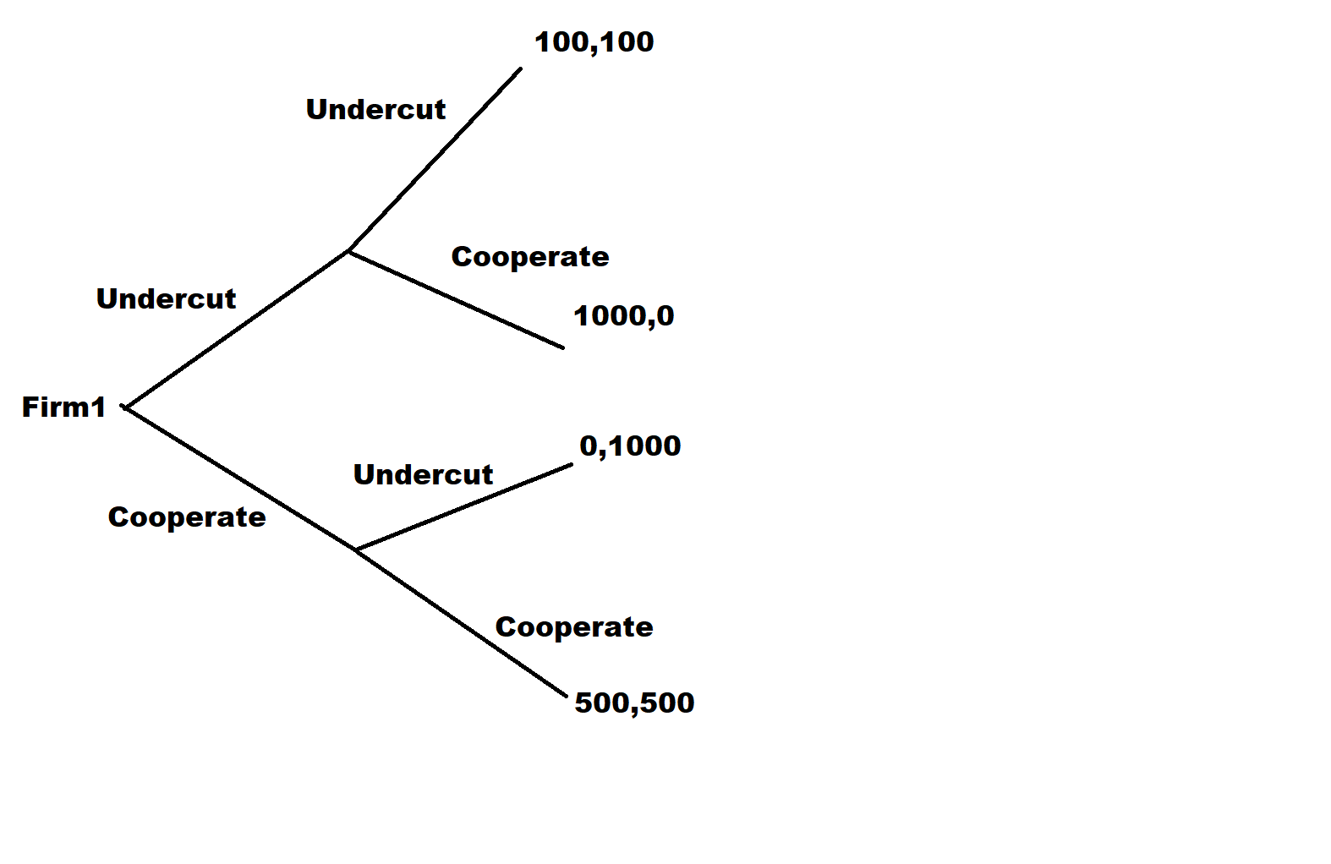
Here in the event that "firm1" decide to "undercut" at that point "firm2" will pick undercut and both will get "100" as a result. In the event that "firm1" decide to "participate" at that point "firm2" will pick undercut and both will get "0" and "1000" separately as a result.
Thus, as a reasonable player "firm1" choose to pick "undercut" and the NE is "undercut, undermined" will get result "100, 100".
c).
Here in this game there don't have any first mover advantage. Since in the former case and in the last case the NE are same. Thus, there don't have any first mover advantage.
d).
On the off chance that a similar game is player for a very long time, at that point additionally participation won't conceivable. Since in the last time frame both will cheat by picking "undercut" to expand their result. In this way, both will proceed to "undercut" structure the first time frame. In this way, the collaboration is unimaginable if the game is played for a limited quantities of periods.

e).
To sustain cooperation, that is the long run payoff from cooperating discounted by r should be greater than the payoff from undercutting
Payoff from Cooperation Payoff from undercutting
Payoff from cooperation (1)
Payoff from undercutting (2)

To sustain cooperation Equation (1) Equation (2)
Using the sum of an infinite geometric series
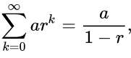
on the LHS , a = 500 & on the RHS, a = 100
500 / (1-r) 1000 + 100/(1-r)
400/ (1-r) 1000
400/1000 (1-r)
2/5 (1-r)
2/5 - 1 -r
-0.6 -r
r 0.6 (multiplying on both sides by -1
Thus the discount rate r is not enough for cooperation the discount rate, r, must be at least 0.6 so that cooperation is optimal.

4.

5. Competition Policy (20 points)

Mergers are one of the business expansion strategies that the firm often utilized to increase overall profitability. Here, one firm merges with another by purchasing a large number of shares from another company. Both firms lose their independent existence and work in a combined one firm. Additionally, mergers may give firms lower cost-benefit and enlarge market share.
a)
Pre-merger quantity equations:
TR1=50q1−5q21−5q1q2MR1=50−10q1−5q2MC1=20Π1=50−10q1−5q2−20=30−10q1−5q2q1=3−0.5q2TR2=50q2−5q22−5q1q2MR2=50−10q2−5q2MC2=20Π2=50−10q2−5q1−20=30−10q2−5q1q2=3−0.5q1TR1=50q1−5q21−5q1q2MR1=50−10q1−5q2MC1=20Π1=50−10q1−5q2−20=30−10q1−5q2q1=3−0.5q2TR2=50q2−5q22−5q1q2MR2=50−10q2−5q2MC2=20Π2=50−10q2−5q1−20=30−10q2−5q1q2=3−0.5q1
Post-merger:
Premerger industry output and price are: Q = 4 and P = $30
Post-merger there will not be individual demand curve but the market demand curve. The quantity decreased with price rise.
MR=MC50−10Q=2030=10QQ=3P=35MR=MC50−10Q=2030=10QQ=3P=35
b)
DWL=4∫3(Ppre−MCPRE).dx=(30−20).dx=10DWL=∫34(Ppre−MCPRE).dx=(30−20).dx=10
Thus premerger deadweight loss is equal to 40 and post-merger is 30. Thus merger is beneficial.
c)
Total surplus before merger=
=(30−0)(4−0)=120=(30−0)(4−0)=120
Total surplus post-merger=
=(35−0)(3−0)=105=(35−0)(3−0)=105
This merger is not advisable. Total surplus has decreased with merger.
d)
Cost savings before merger=
MC=15P=50−5QMR=50−10QMR=MC50−10Q=15Q=3.5P=50−5(3.5)=32.5MC=15P=50−5QMR=50−10QMR=MC50−10Q=15Q=3.5P=50−5(3.5)=32.5
e)
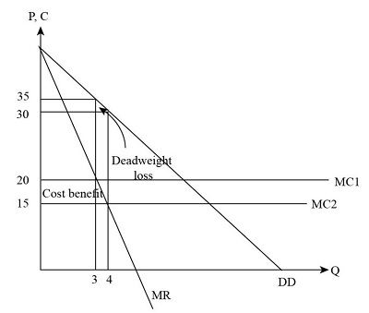
f)
Cost savings=
=(20−15)(4−3)=5=(20−15)(4−3)=5
g)
DWL=4∫3(Ppre−MCPRE).dx=(32.5−15).dx=17.5DWL=∫34(Ppre−MCPRE).dx=(32.5−15).dx=17.5
h)
Pre-merger DWL=
=(30−20)(4−3)=10=(30−20)(4−3)=10
Post-merger DWL with MC=15
=(32.5−15)(3.5−3)=8.75=(32.5−15)(3.5−3)=8.75
i)
Post-merger DWL with MC=20 is less hence this merger is good. But if MC=15, this increases price but DWL is lesser. Hence with cost synergies merger is more viable.
Total surplus before merger was 120. With cost MC=15, new Total surplus is:
=(32.5−0)(3.5−0)=113.75=(32.5−0)(3.5−0)=113.75
Considering further decrease in total surplus this merger is again not advisable.

